INSTALLATION MANUAL

- Download “Paket5!.rar” and “History.rar” from post nr. 1. In some cases when you download file extension is not “.rar” and you can’t extract file. Just change extension to “.rar” and file will be ok!
- Extract “Paket 5!” file to your desktop.
- Close Mt4 if its open.
- Right click on your Mt4 icon and open properties.
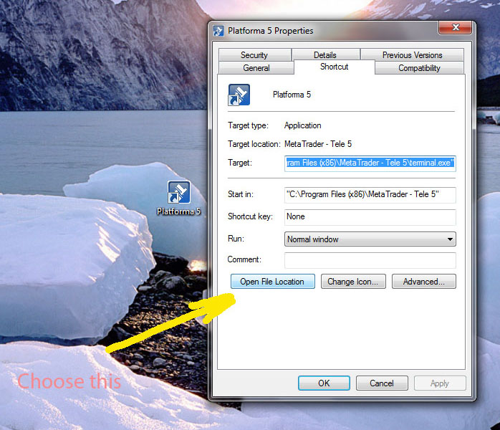
- Chose Open File Location.

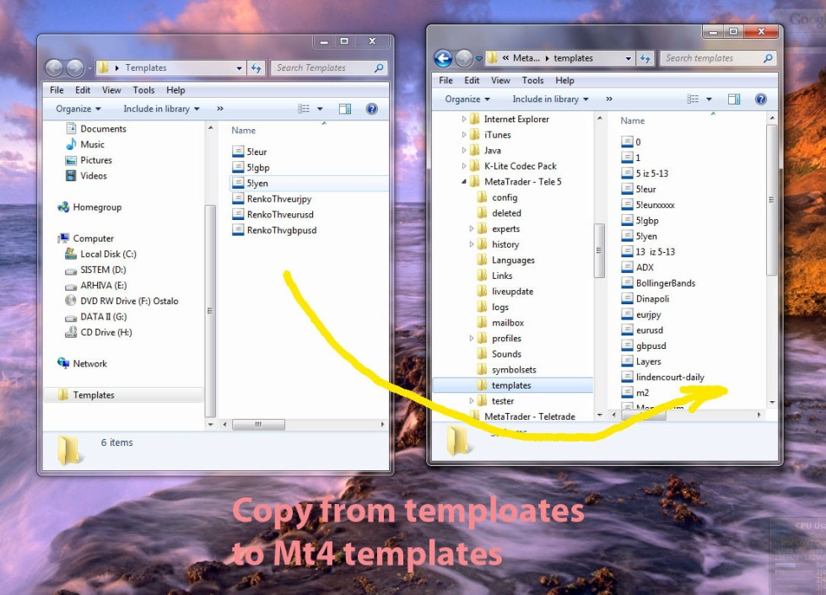
- Copy files from extracted folder templates to your Mt4 folder templates.

- Copy files from extracted Profiles folder to your MT4 folder Profiles.
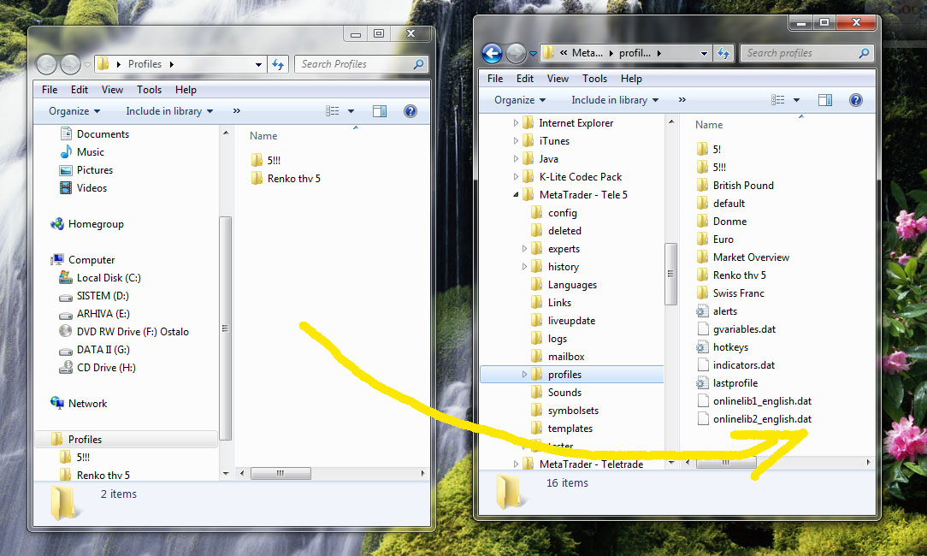

- Copy ”RenkoLiveChart 3.3” from extracted experts folder to your Mt4 experts folder.
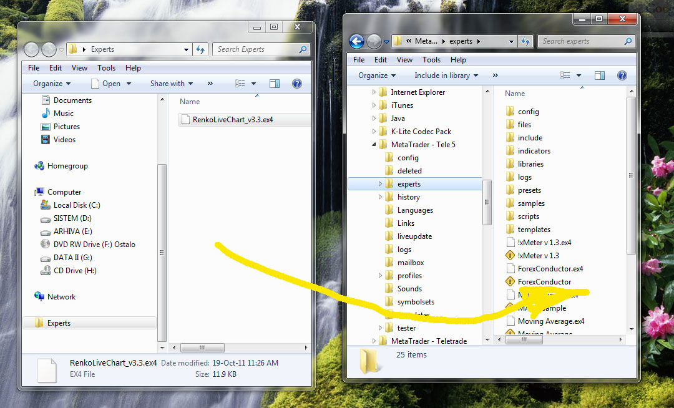

- Copy files from extracted Indicators folder to your Mt4 expert+indicators folder.
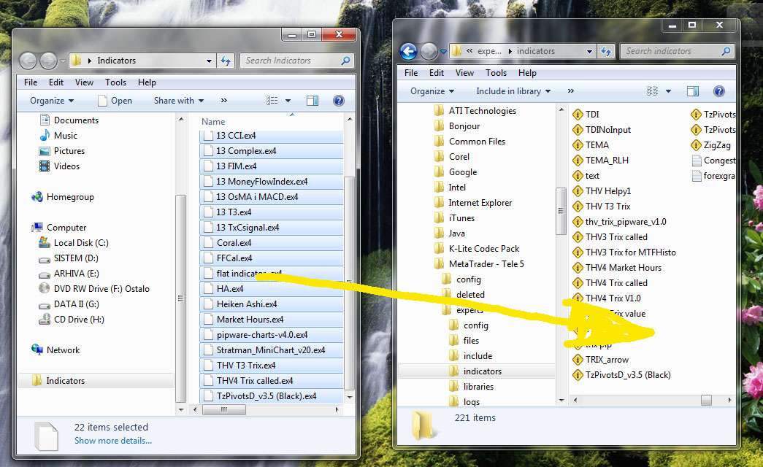

- Copy Stratman font from extracted folder Font to your C:/windows/fonts folder.
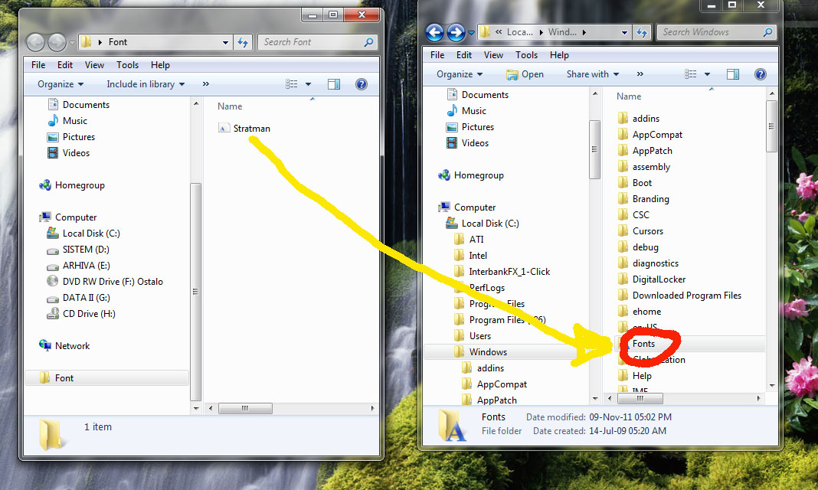

- Exttract “History.rar “ to desktop.

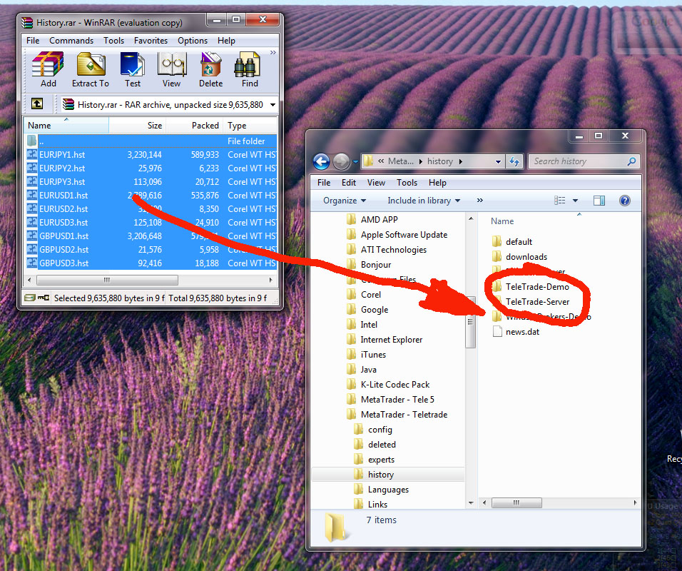
- Copy all extracted files to your Mt4 history+yourbroker folders

- Start your Mt4 platform wait 30 seconds and then restart your Mt4 platform
- Go to File+Profiles and chose Renko Thv 5 or 5!
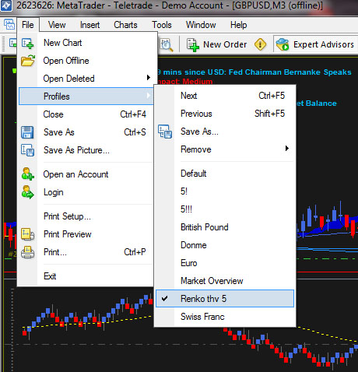

- Wait 30 seconds after profile will be applied and then restart your Mt4 platform
Please check your expert advisors to be green.

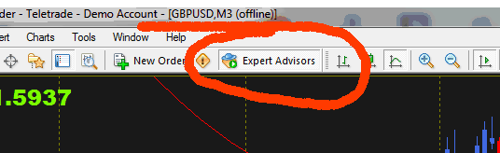

If you don't see last two indicators on the bottom of your chart, just refresh chart using template for that pair.

There is a lot of problems people found out during installation with the different windows systems.
Sometimes works if you just install Mt4 on the different partition than Windows.
At the end of a day, you can always install Mt4 on your USB and it will work perfectly.

Regards,

Mihailo

